**Lab 7 and 8**

**Create an app, can use Free API & develop its "Flask -> HTM:" based front-end**

**Explanation:**

This Flask application is designed to fetch and display NASA's Astronomy Picture of the Day (APOD) using NASA's public API. It starts by importing the necessary modules, including Flask for building the web application, render_template for rendering HTML templates, and requests to make API calls. The application initializes a Flask instance and sets up two key variables: NASA_API, which holds the API key required for authentication, and APOD_URL, which is the endpoint for retrieving APOD data.

When a user visits the homepage (/), the index() function executes. It sends a GET request to NASA’s APOD API with the API key as a parameter. The API responds with a JSON object containing details about the astronomy picture, including its title, image URL, and explanation. This data is then passed to index.html using the render_template() function, allowing the frontend to display the fetched information dynamically.

Finally, the Flask app is run using app.run(debug=False), which starts a local web server, making the application accessible at http://127.0.0.1:5000/. When users visit this URL, the latest APOD image, along with its details, is displayed on the webpage. This simple yet powerful application provides a real-time, interactive way to explore NASA’s daily astronomical images.

**Output:**

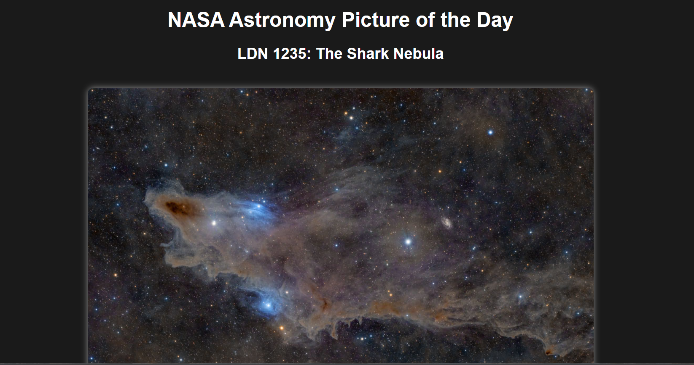

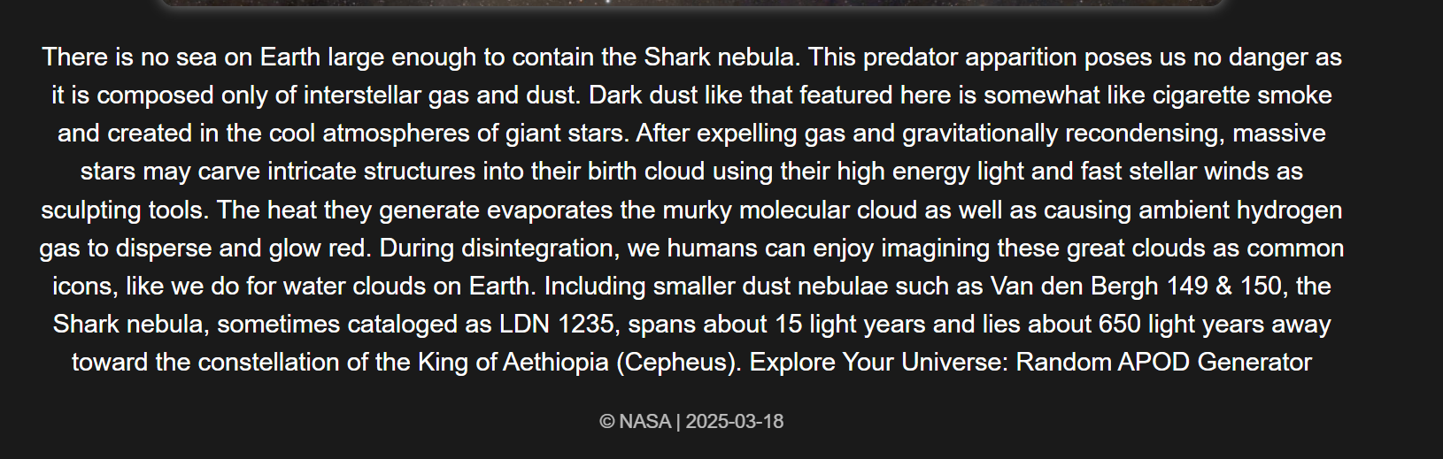

**Code:**

* **app.py:**

from flask import Flask, render_template

import requests

app = Flask(__name__)

NASA_API = "hpDUugVbKilEQl3SLpViHw4hNFOz0iHq313KZY3i"

APOD_URL = "https://api.nasa.gov/planetary/apod"

@app.route("/", methods=["GET"])

def index():

par = {"api_key" : NASA_API}

response = requests.get(APOD_URL, params=par)

apod_data = response.json()

return render_template("index.html", apod = apod_data)

if __name__ == "__main__":

app.run(debug=False)

* **index.html:**

<!DOCTYPE html>

<html lang="en">

<head>

<meta charset="UTF-8">

<meta name="viewport" content="width=device-width, initial-scale=1.0">

<title>NASA APOD</title>

<style>

body {

font-family: Arial, sans-serif;

text-align: center;

background-color: #1a1a1a;

color: white;

margin: 0;

padding: 0;

}

h1 {

margin-top: 20px;

font-size: 2rem;

}

img {

width: 80%;

max-width: 800px;

border-radius: 10px;

margin-top: 20px;

box-shadow: 0px 0px 10px rgba(255, 255, 255, 0.5);

}

p {

max-width: 80%;

margin: 20px auto;

font-size: 1.2rem;

line-height: 1.5;

}

.footer {

margin-top: 20px;

font-size: 0.9rem;

opacity: 0.7;

}

</style>

</head>

<body>

<h1>NASA Astronomy Picture of the Day</h1>

<h2>{{ apod.title }}</h2>

<img src="{{ apod.url }}" alt="Astronomy Picture of the Day">

<p>{{ apod.explanation }}</p>

<p class="footer">© NASA | {{ apod.date }}</p>

</body>

</html>